Oxhey Consulting Limited 21 Brookside Road Watford

United Kingdom WD19 4BW

Dear Sir/Madam,

Please accept this letter as a confirmation that BOUARFA Rime has completed an online internship at Oxhey LTD between the dates of 03/07/2023 and 29/09/2023.

This 3 months placement mainly focused on website development with the view to build towards an innovative and customer-orientated website for our recruitment business.

I can confirm that Rime has been a great asset to our team and her efforts have played a part in our continued success as a relatively new recruitment firm and we look forward to collaborating with her in the future.

Please do not hesitate to contact me if you require anything else.

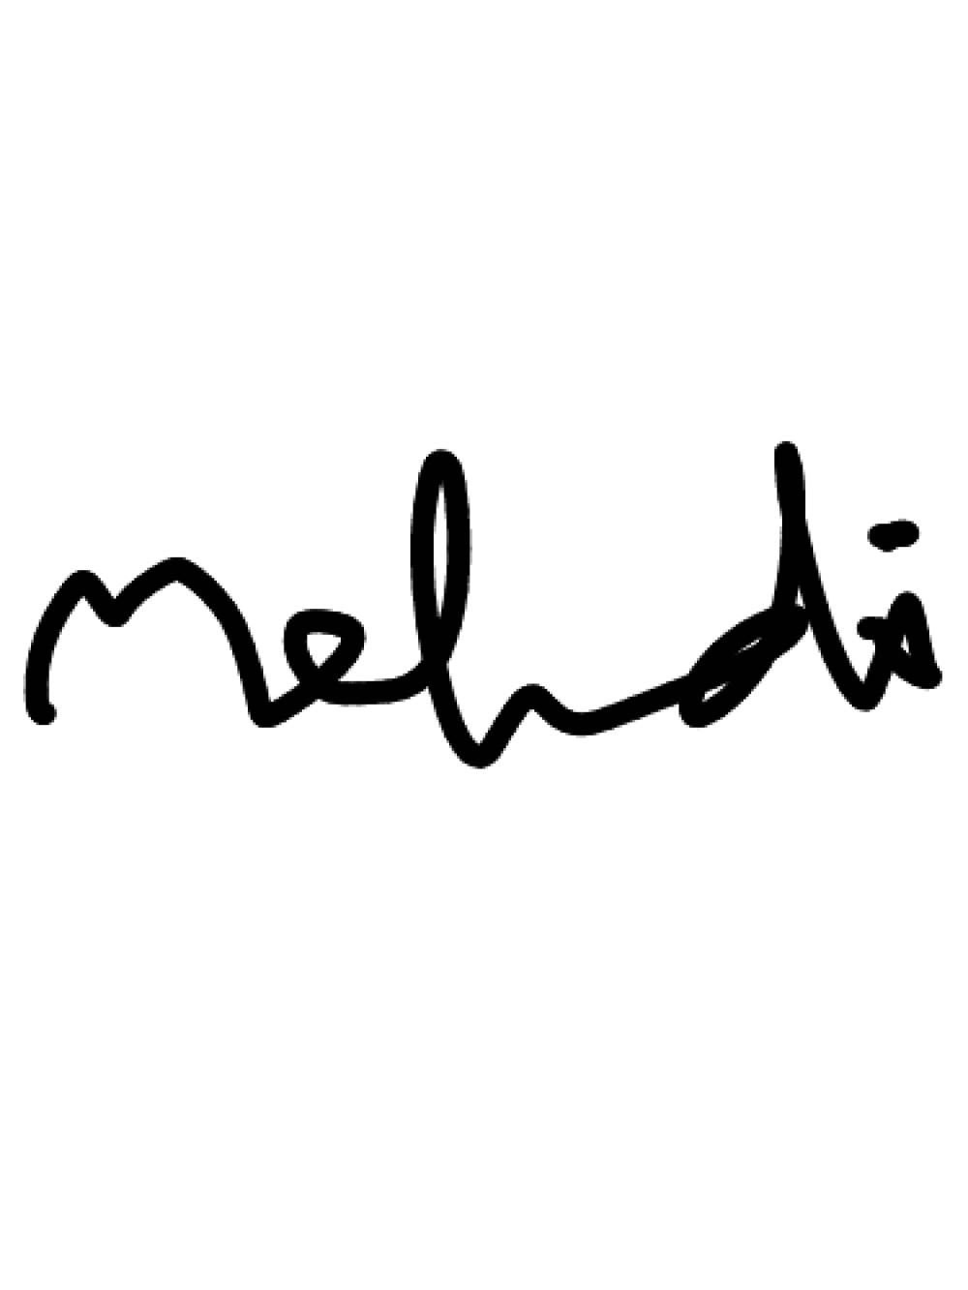Sincerely,

Mehdi Datoo – Director, Oxhey Consulting Limited Email: [oxhey@mail.com](mailto:oxhey@mail.com)

Tel: +447517621620